Progression Log: 26/01/2018

## ARTWORK

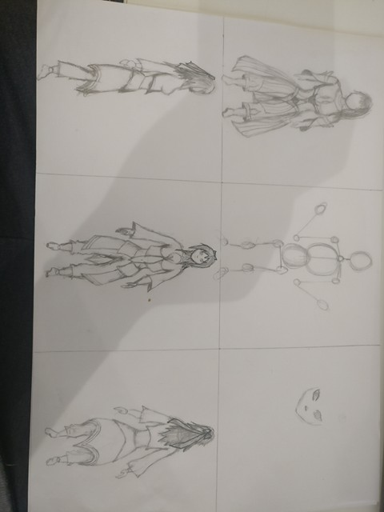Since my game revolves heavily on its art and animation, that’s where I wanted to start; I started designing my first initial character. I decided to start on the character designs because do not have any qualifications or experience in art or animation (as you can probably tell from the initial sketches), so It would take up a lot of my time to learn different techniques and programmes to use.

I wanted my characters to look very similar to those of the characters in the JRPG genre since it is where the idea for my game came from.

## THE GAME ITSELF

For the actual game itself I created a basic game object (a capsule) that could move around using the directional and/or WASD keys and jump with the space key. I also added camera movement whenever the mouse is moved.

A GIF of the movement can be found here: <https://gyazo.com/718e4cdfa24d32f222cbb4b262556ae6>